Lab3: Basic SELECT- SQL Commands:

### **Objectives**: Study one-table query and aggregation using SELECT SQL commands

**Estimated Time :** 2 hours

Lab Instruction

**Data Manipulation (DML) Commands**

DML consists of SELECT, INSERT, UPDATE and DELETE commands and the last three commands are introduced in Lab2. This lab presents the SELECT command which use to retrieve data from a database. Additional commands are also presented such as USE command to specify the working database, SHOW TABLES to list of tables in the database, and DESC command is for describing a table’s structure.

1. Write SQL command to drop database named world (if exist).
2. Create database named world.

CREATE DATABASE world;

USE world;

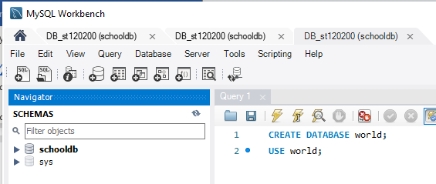

**Click to execute the commands**

Fig. 1 Create database

1. For create all tables, we will Run Script ‘world.sql’ to create and insert data.
2. List all tables

show tables;

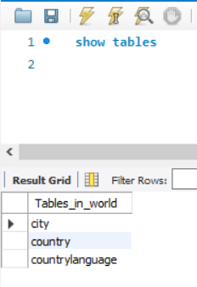

Fig. 2 Show all tables

1. Describe a table’s structure

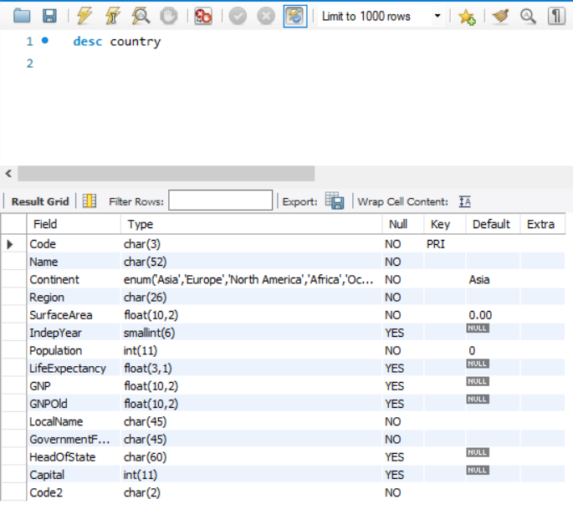

Fig. 3 Show table structure

1. [Task1] List all countries.

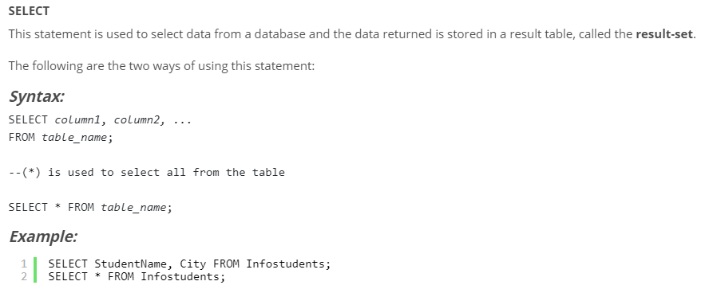

Fig. 4 SELECT statement syntax

1. [Task2] List all DISTINCT region in table country and sort the desired results in descending order.

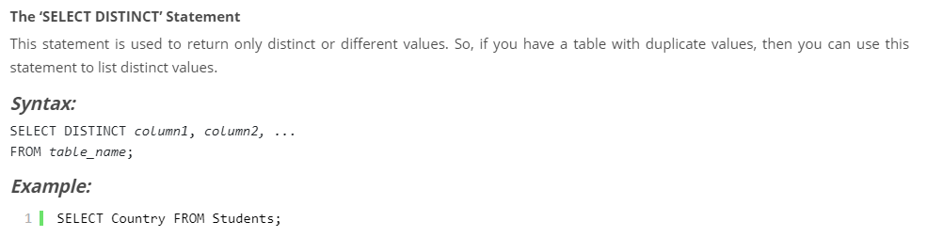

Fig. 5 SELECT DISTINCT statement syntax

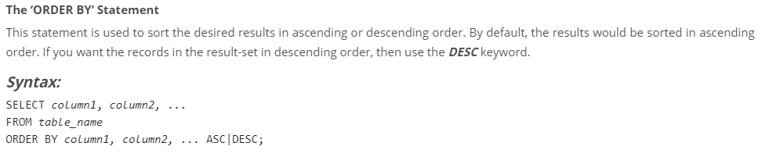

Fig. 6 ORDER BY statement syntax

1. [Task3] Does the WORLD database consist of “Thailand”?
2. [Task4] Find all the countries where the local name is the same as the common name

**Condition clause**

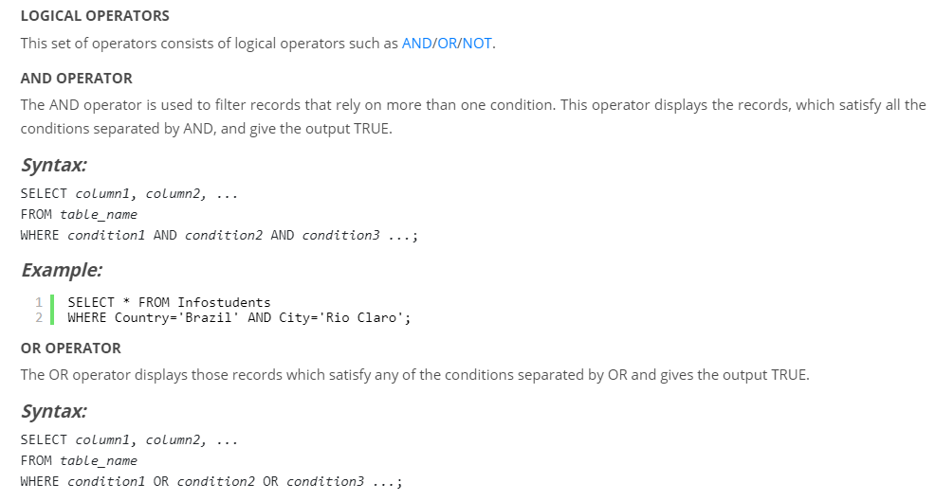

Fig. 7 AND Operator syntax

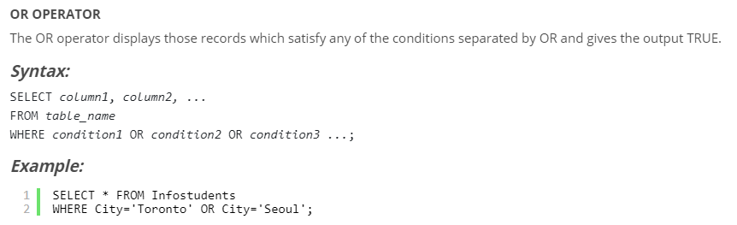

Fig. 8 OR Operator syntax

Example: SELECT * FROM country where Continent = 'North America' OR Continent = 'South America'

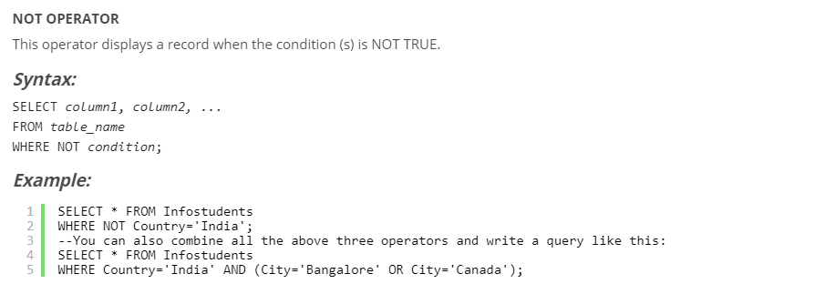

Fig. 9 NOT Operator syntax

**Comparison Operators**

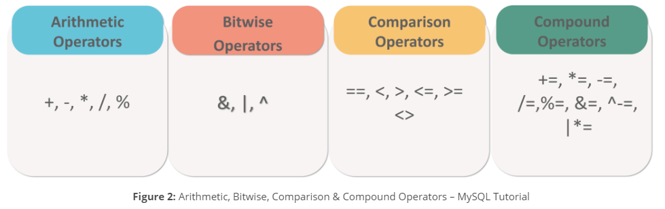

Fig. 10 Comparison Operators

Example: SELECT * FROM country WHERE NOT name ="Thailand";

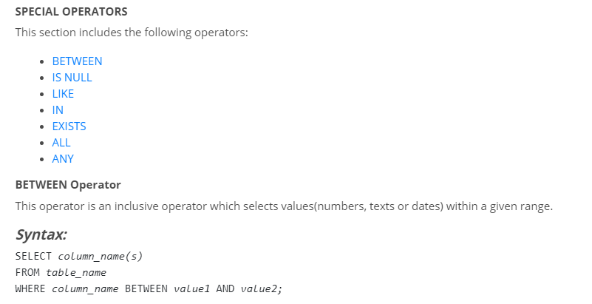



Fig. 11 Between Operator syntax

Example: SELECT * FROM country WHERE LifeExpectancy between 30 and 40

*Remark LifeExpectanc is a statistical measure of the average time an organism is expected to live, based on the year of its birth*

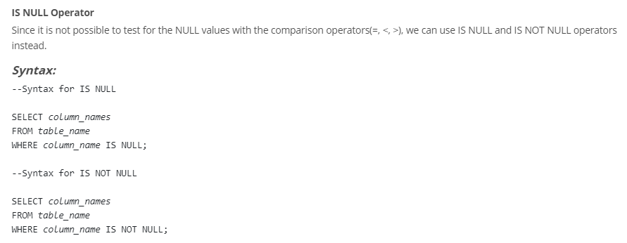

Fig. 12 IS NULL Operator syntax

Example: SELECT * FROM country WHERE LifeExpectancy IS NULL;

SELECT * FROM country WHERE LifeExpectancy IS NOT NULL

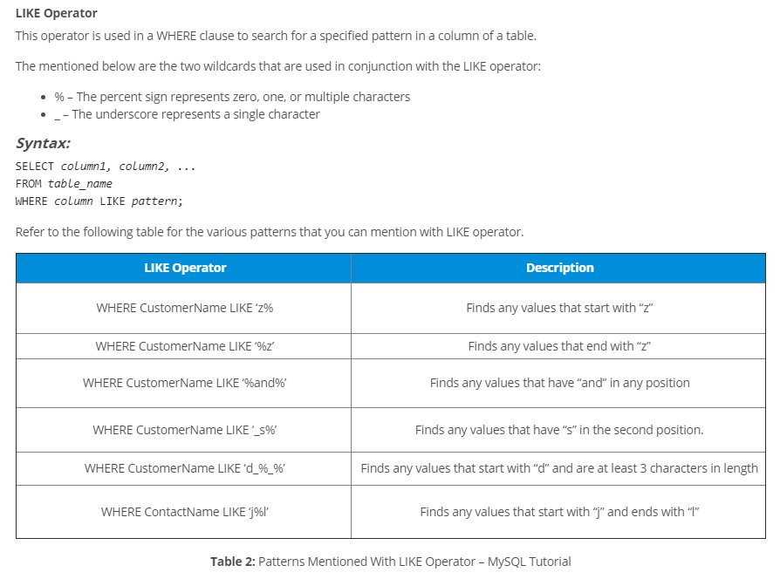

Fig. 13 LIKE Operator syntax

1. [Task5] Find all countries in continents of Antarctica and Asia.
2. [Task6] Find all countries except countries in continents of Antarctica and Asia.
3. [Task7] Find all countries having Name start a with ‘N’ and ends with ‘D’.
4. [Task8] Find the populations of cities in Thailand having Population between 100,000 and 200,000
5. [Task9] Find out the top three of the most populous cities in Thailand.
6. [Task10] Which countries in Asia have a life expectancy more than 80?
7. [Task11] Which country has the longest life expectancy including Japan, Thailand, and China?

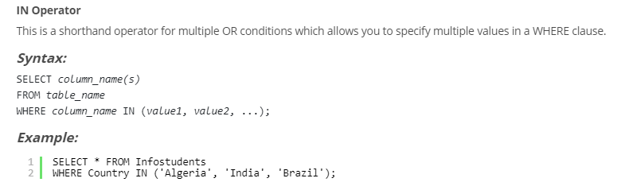

Fig. 14 IN Operator syntax

1. [Task12] Find the total population in Thailand.

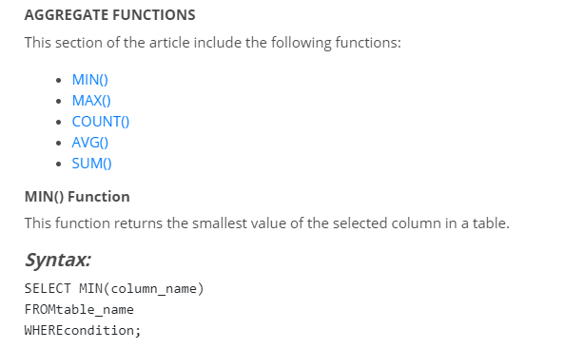

Fig. 15 Aggregation Functions

1. [Task13] Find the number of countries for each continent.

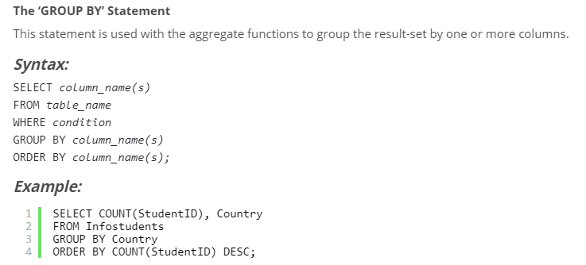

Fig. 16 GROUP BY statement syntax

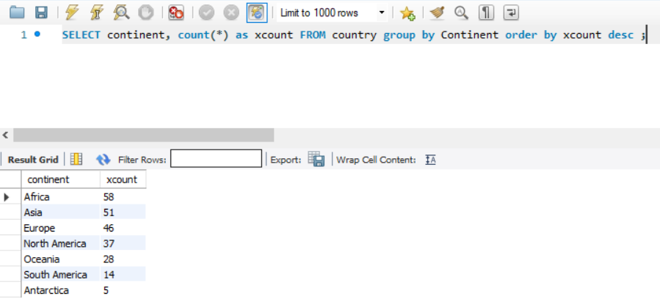

1. [Task14] Which continent has the most/least countries? (2 Queries)
2. [Task15] Find the most population in each country.
3. [Task16] Find the life expectancy of people from each continent having an average life expectancy less than 70 years.

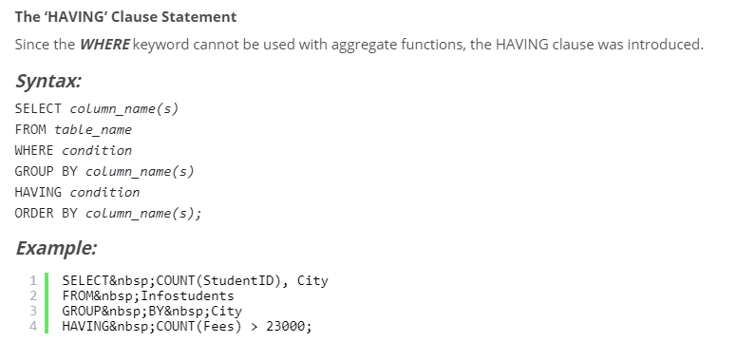

Fig. 17 HAVING statement syntax

1. [Task17] Find a Continent that have the number of country greater than 30.

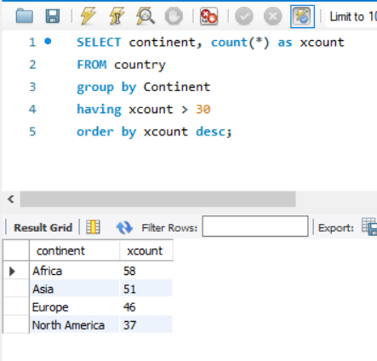

Lab Submission

Submission System: Course LMS (primary) ,  
 Email: [dmmlab2020@gmail.com](mailto:dmmlab2020@gmail.com) (In case you cannot submitted in Course LMS)  
 For example; you want to submit LAB 3 and your id is st120200, your e-mail subject and your assignment filename must be LAB3_st120200

Total TASKS: 17